# Lab: HTML Forms and Styling

Problems for exercises and homework for the ["HTML and CSS" course @ SoftUni](https://softuni.bg/courses/web-fundamentals-html5). Submit your solutions in the SoftUni judge system at <https://judge.softuni.bg/Contests/409/Lab-HTML-Forms-and-Styling> .

## Login Form Images

Create a Web page (HTML5 + CSS3 + images) that looks and behaves like the screenshots below:

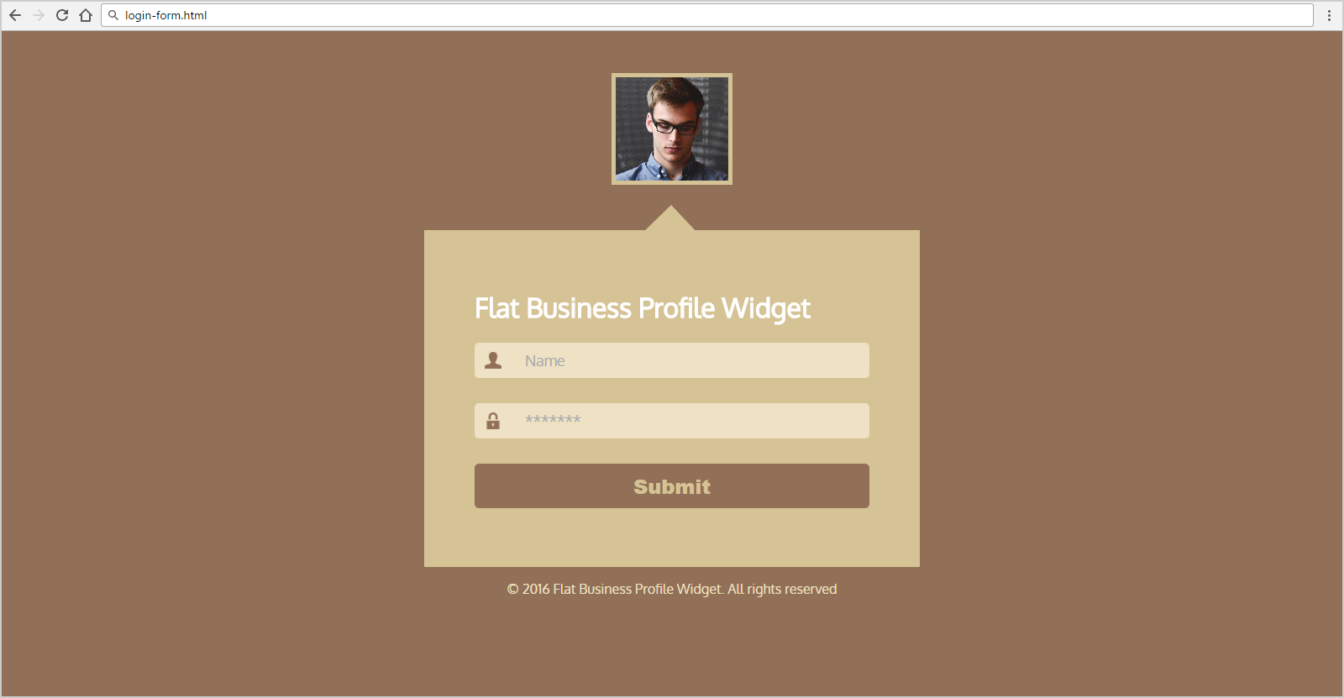

Create files: "**login-form.css**" and "**login-form.html**"

### Steps to Follow

Start with the **site header**:

* @import url('<https://fonts.googleapis.com/css?family=Oxygen>');
* Body
  + Background: **#927057**;
  + Text-Color: **#ffffff;**
  + Padding: 20px;
* Main
  + Width 470px;
  + margin: 50px auto 0;
  + Padding: 50px 60px 70px 60px;
  + Baclground**:** #d5c395;

Test the site in the browser:

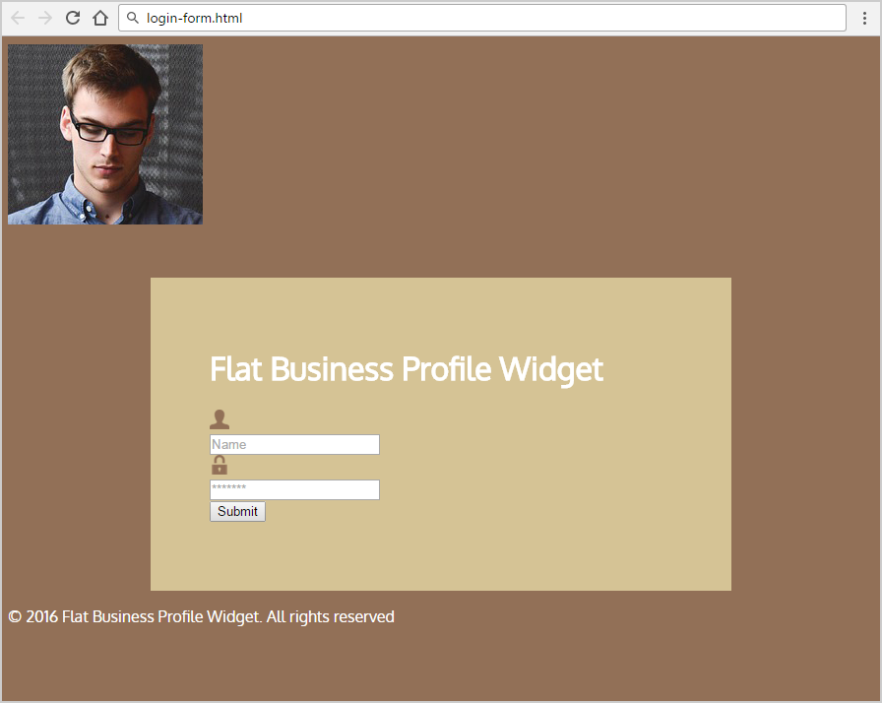

Use: div with class="image-container" as a container to hold the profile image

* Main:Before
  + Position: **Absolute;**
  + Top: **-30px;**
  + Left: **259px;**
  + Background: url(…) no-repeat 0 0;
  + Display: **block;**
  + Height: **35px;**
  + Width: **68px;**
  + Content: **"";**
* **<footer>**
  + Text-Size: **1em;**
  + Text Color: **#EFE1C4**
  + Text-Align: **center;**
* **div.image-container**
  + Center the div
  + Margin top: **50px;**
* Image
  + Border: 5px solid #d5c395;
  + Height: 123px;
* Input for **password** and **username**
  + Outline:None**;**
  + Border: **none;**
  + Background**: #efe1c4;**
  + Padding: **10px 10px 10px 60px;**
  + Width: **85%;**
  + Text-size: **1.1em;**
  + Text-Color: **#927057;**
  + border-radius: **5px;**
  + Margin-bottom: **30px;**

Test the site in the browser:

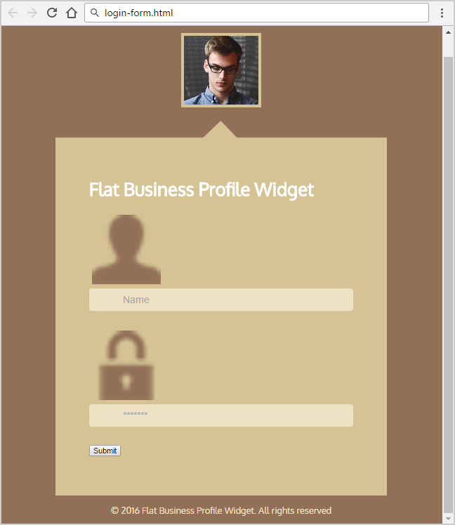

Now style input with type="submit":

* **Input[type="submit"]**
  + Outline**: none;**
  + Border: **none;**
  + Background**: #927057;**
  + Padding: **10px;**
  + Width: **100%;**
  + Max-Width: **500px;**
  + Text-size: **1.5em;**
  + Text-Color: **#d5c395;**
  + border-radius: **5px;**

Use divs as a parents for images (username) and (password) and setposition **relative**

* **Img src="img/pass.png" and Img src="img/user.png"**
  + Position**: Absolute;**
  + Left: **12px;**
  + Top: **11px;**
  + Width: **20px;**
  + Height: **20px;**
  + Border: **none;**

**Test** the site

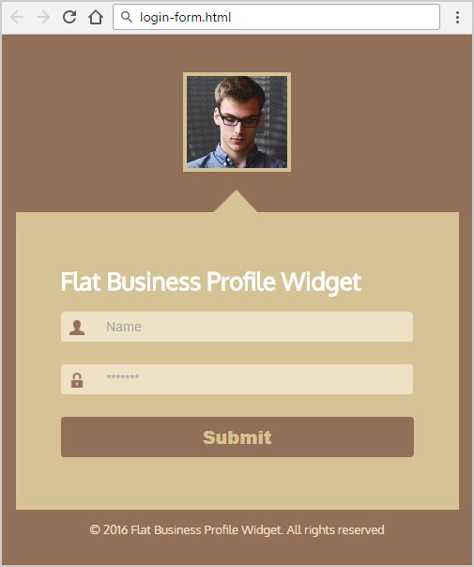

## Login Form Font Awesome

Create a Web Page like the following.

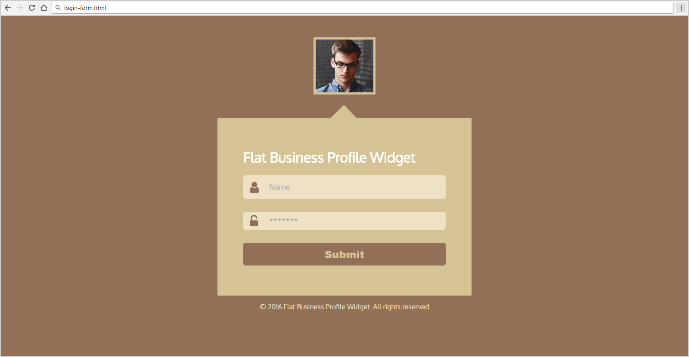

### Constrains

Use **Font Awesome** iconsfor img in the input fields

### Hints

* @import url('<https://fonts.googleapis.com/css?family=Comfortaa:700|Open+Sans:400,700>');
* @import url('<https://maxcdn.bootstrapcdn.com/font-awesome/4.7.0/css/font-awesome.min.css>');
* <i class="fa fa-user" aria-hidden="true"></i>
* <i class="fa fa-unlock-alt" aria-hidden="true"></i>

## Login Form Bg Images

Create a Web Page like the following.

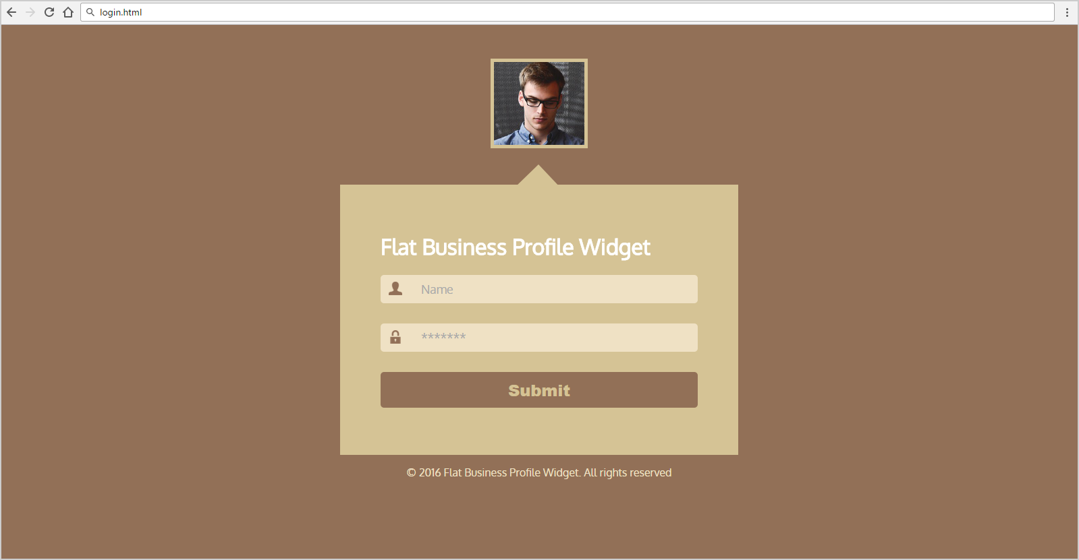

### Constrains

Use **Background-image** forimagesin the input fields

## Contact Form

Create a Web Page like the following.

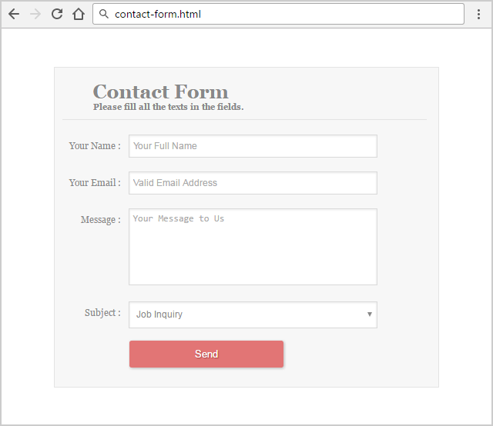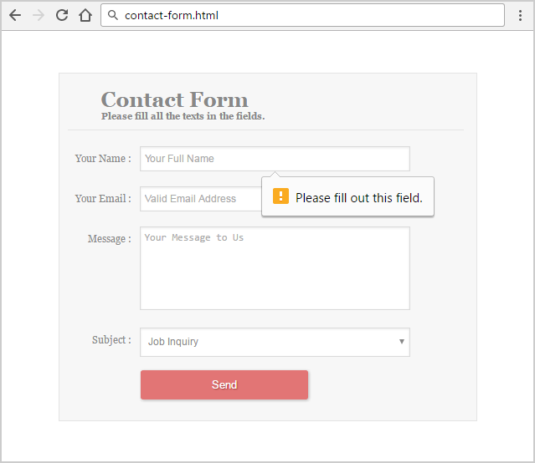

### Constrains

Font: Georgia, "Times New Roman", serif;

Text Color: #888, #FFF;

Background Color: #F7F7F7, #E27575;

## Arranging the Widths

Create a Web Page like the following.

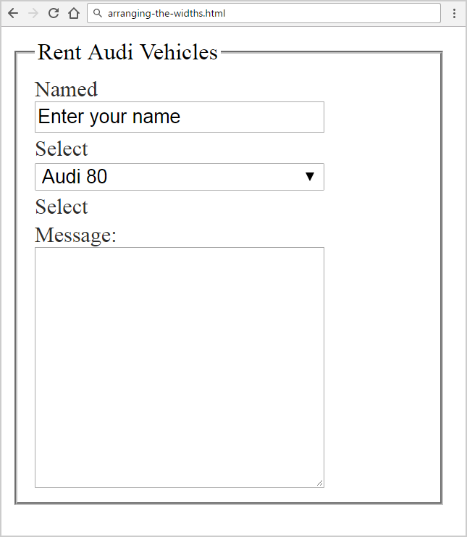

### Constrains

Form Width: **300px;**

Text Color: #2D2D2D;